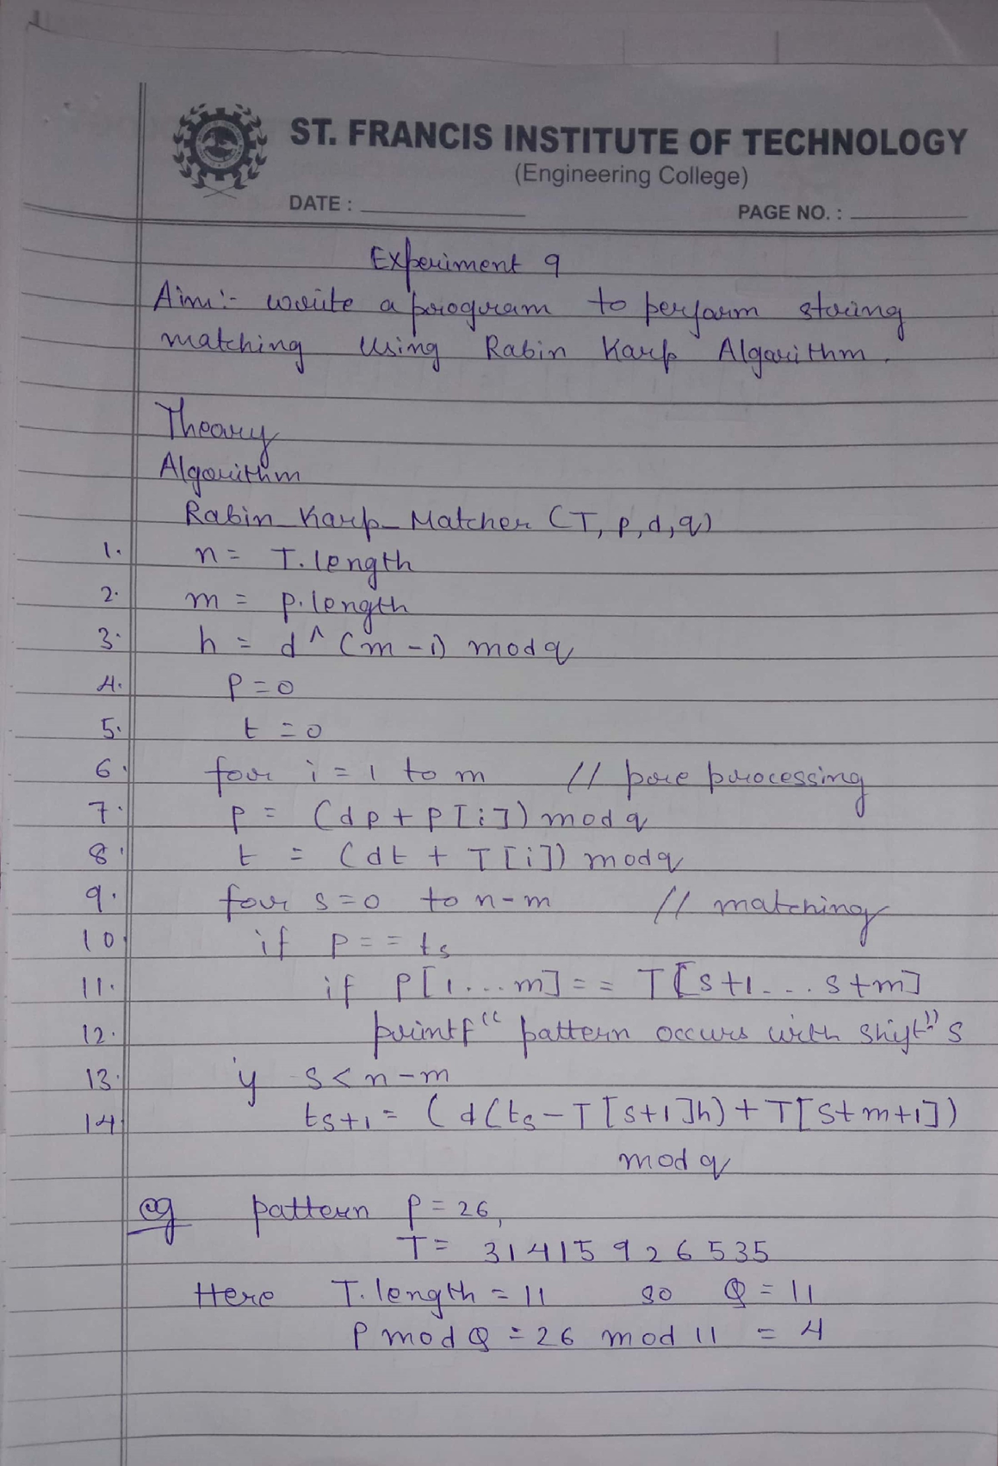

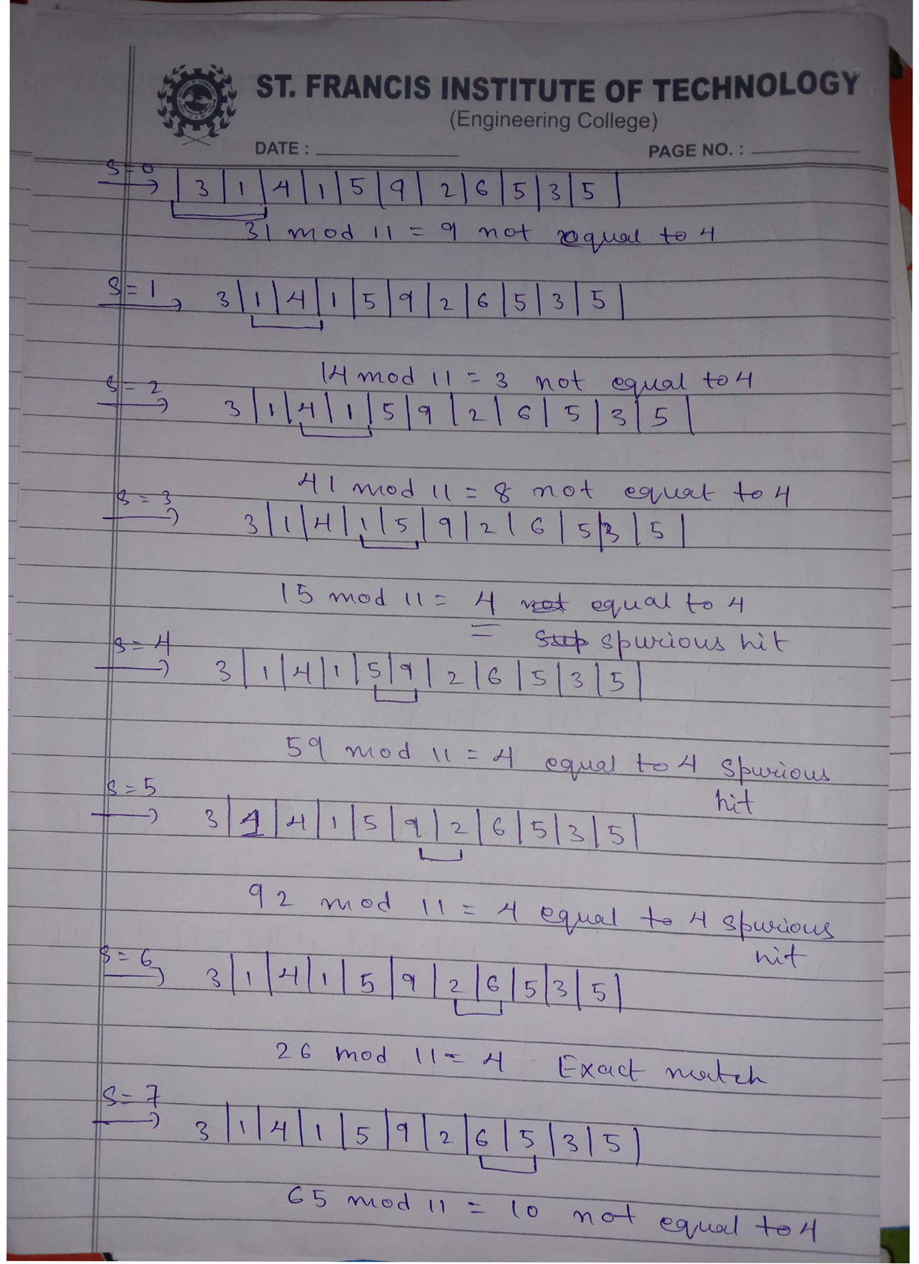

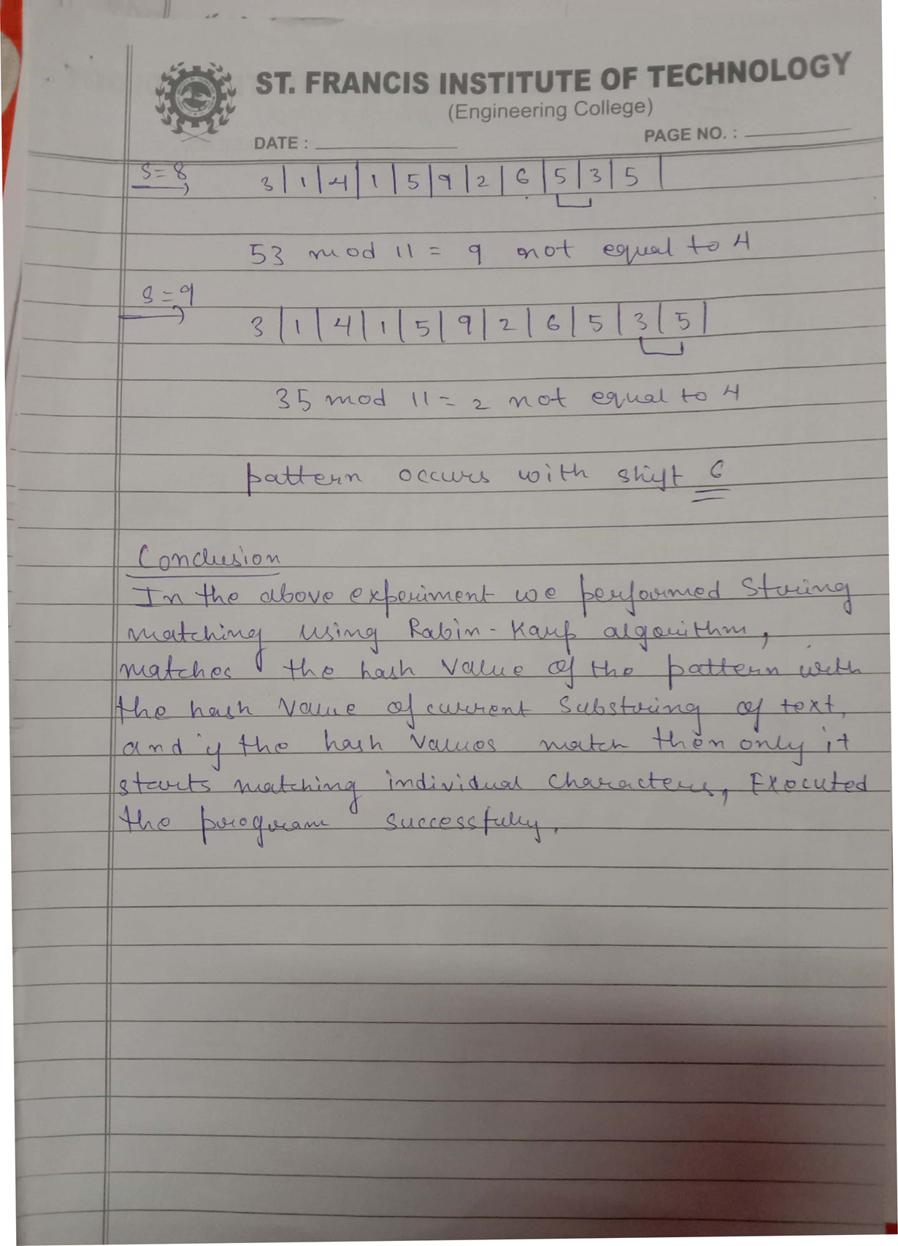

#include<stdio.h>

#include<conio.h>

#include<string.h>

#include<math.h>

#define d 10

void RabinKarpStringMatch(char \*, char \*, int);

void main()

{

char \*Text, \*Pattern;

int Number = 11; //Prime Number

clrscr();

printf("\nEnter Text String : ");

gets(Text);

printf("\nEnter Pattern String : ");

gets(Pattern);

RabinKarpStringMatch(Text,Pattern,Number);

getch();

}

void RabinKarpStringMatch(char \*Text, char \*Pattern, int Number)

{

int M,N,h,P=0,T=0, TempT, TempP;

int i,j;

M = strlen(Pattern);

N = strlen(Text);

h = (int)pow(d,M-1) % Number;

for(i=0;i<M;i++) {

P = ((d\*P) + ((int)Pattern[i])) % Number;

TempT = ((d\*T) + ((int)Text[i]));

T = TempT % Number;

}

for(i=0;i<=N-M;i++) {

if(P==T) {

for(j=0;j<M;j++)

if(Text[i+j] != Pattern[j])

break;

if(j == M)

printf("\nPattern Found at Position : %d",i+1);

}

TempT =((d\*(T - Text[i]\*h)) + ((int)Text[i+M]));

T = TempT % Number;

if(T<0)

T=T+Number;

} }

